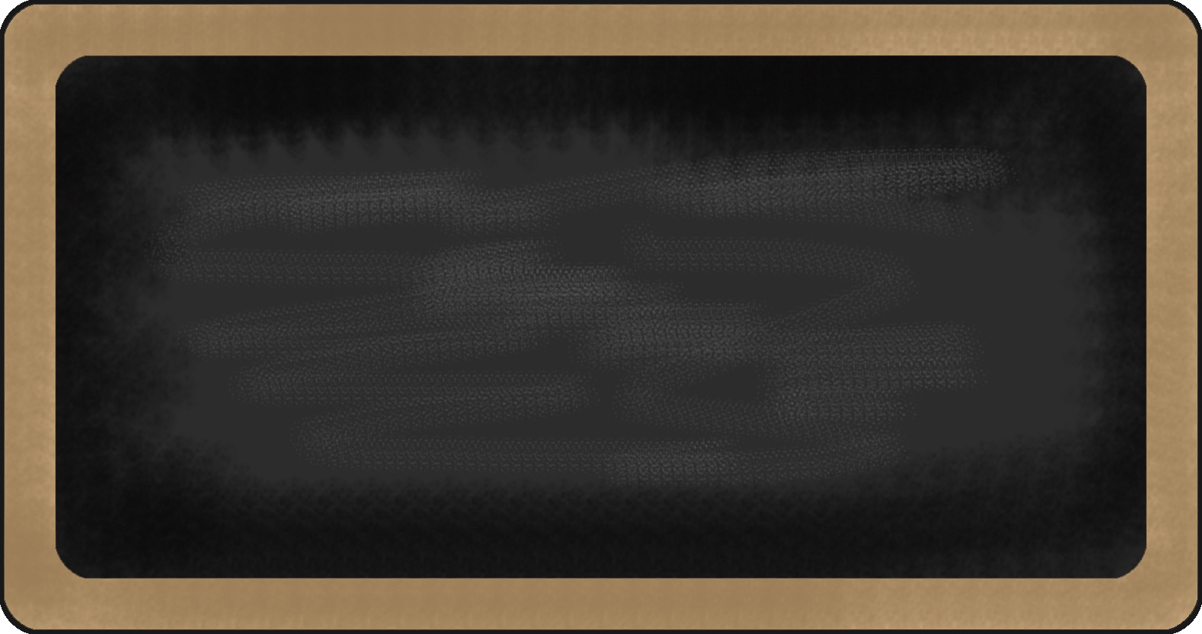

Kindergarten News

Sight Words Review

a, and, I, is, it, to, the, was, like, me

Upcoming events
December 4th – Last day to buy tickets for the students’ Christmas Dinner!
December 5th – Wear a Santa hat, Elf hat or reindeer antlers or any festive head wear for $1 (Fundraiser for the Fredericton Community Kitchen)
December 11th – Christmas Concert (1st Show – 9:00 am/2nd Show – 11:00 am)
December 12th – Wear a festive sweater for $1 (Fundraiser for the Fredericton Community Kitchen)
December 13th – Christmas Dinner for students ($5.75)

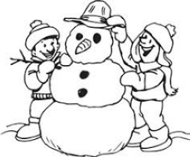

Notes from the teacher:
Thank you for meeting with me! I thoroughly enjoyed our discussions.
Dress for the weather! Continue working on building independence in your child’s ability to put on and take off their outer wear. Thank you! ☺
We are still without a Librarian! ☹ We are hoping to find one soon so that our students will be able to resume borrowing books. Thank you for your patience!
Please continue to practice letter recognition & sounds, sight words and counting regularly.
If you have any questions or concerns please feel free to contact me at rolly.sidik@nbed.nb.ca, or call the school, (506) 453-5438.

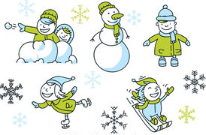

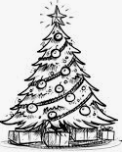
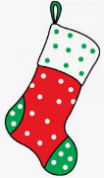

What we are learning this week:

Reading | Writing | Math | You and Your World
- Letters: J, W  - Sight Words Review: a, and, I, is, it, to, the, was, like, me  - Strategy: Lips the Fish – Get your mouth ready. Say the first sound.  - Review letters: s, a, t, i, p, n, c/k, e, h, r, m, d, g, o, u, l, f, b | - Practice proper letter formations for: j, w, f, b, u, l, o, p, n, t, i, s, a, c/k, e, h, r, m, d, g, o  - Practice reading, writing and spelling sight words  - Practice writing their names | - Say the number sequence 0-10.  - Represent and describe numbers  - Subitizing 1-5 objects  - Relate a numeral to its quantity 6 to 10  - Identify, create and reproduce patterns | - Recognize and respect the various traditions, rituals and celebrations of families  - W.I.T.S. Strategy  - Habit 2: Begin with the end in mind. (I plan ahead and set goals. I do things that have meaning and make a difference. I am an important part of my classroom. I look for ways to be a good citizen.)

